Suncoast Academy
Supply List for Fourth Grade
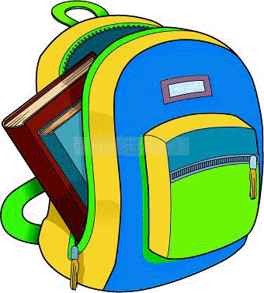
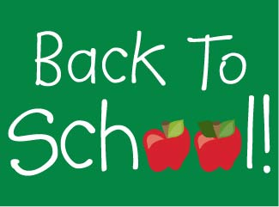
Please bring all supplies listed below to your teacher’s classroom on
Back to School Night on Thursday, August 6, 2020.
All 4th graders will need the following. Please buy the brand specified.
- 1 large, pink Papermate bevel eraser
- 1 pack of 10 Crayola markers (Classic Colors)
- 1 pack of 24 Crayola crayons
- 1 pack of 12 Crayola colored pencils
- 1 pair of scissors
- 2 packs of Ticonderoga pencils (Available at Walmart or office stores)
- 4 Elmer’s glue sticks
- 1 Elmer’s glue bottle
- 1 roll of Scotch tape
- 1 package of 4 Expo Dry Erase Markers (thin)
- 2 pack of wide ruled, lined notebook paper
- 1 pack of Post-It Notes (square, light color)
- 1 package of 10 sheet protectors (Wal-Mart, Staples, or Office Max)
- 1 container of Clorox disinfectant wipes
- 1 large box of tissues
- 1 container of hand soap
- 1 container of hand sanitizer
Girls: Boys:
1 package of colored cardstock 1 package of white cardstock 1 box of gallon size Ziploc bags 1 box of sandwich size Ziploc bags
Please put your child’s name on everything listed below.
- 1 PLASTIC pocket folder – any style – no prongs
- 1 backpack (no wheels) – Needs to have 2 straps
- 1 – 1 inch binder– with inside pockets at front and back, and a clear pocket on the front and back of the notebook – you should be able to slide a piece of paper into the front.
- 1 compact, sturdy umbrella
- 1 pair of Headphones with volume control & 3.5 mm plug – NO EARBUDS (label with your child’s name)
- 1 shoe box with lid (for a craft)

The following supplies are needed for Art/Music/Computer Lab:
Computer Lab – Boys : Clorox Wipes Girls: Hand Sanitizer
Music – 1 pack of 12 pencils
Art – Cheap paper plates

* Your teacher may provide an amended version of this list with class-specific supplies needed.

